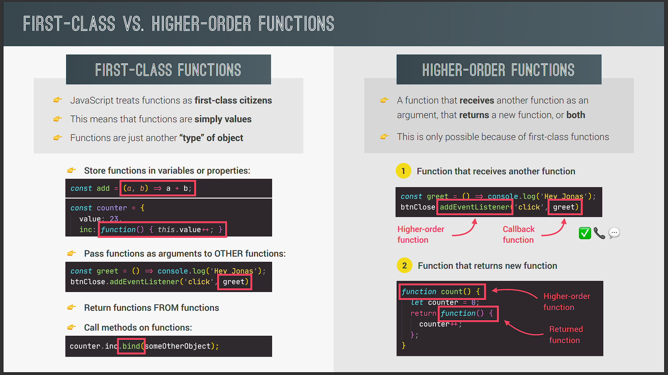

Let's now talk about a fundamental property of the JavaScript language. Which is the fact that it has first class functions. This enables us to write higher order functions. But what's that all about? Well let's see. So JavaScript is a language that has first class functions which in technical terms means that functions are socalled first citizens. In practice that means that functions are simply treated as values. And we already touched on that idea a couple of times before but this is such an important feature of the language that it's worth spending some more time talking about this. Now why does JavaScript work this way? Well it's simply because functions are really just another type of objects in JavaScript. And since objects are values functions are values too. And since functions are values there is a bunch of interesting things that we can do with them like storing them in variables or object properties. And that of course we already did a couple of times before.

So the function values here are marked in red and then you see we create a function expression in the first example and an object method in the second example. So the value in the red rectangle is the function value itself that we can store wherever we like. We can also pass functions as arguments to other functions. And we actually already did that before when adding event listeners or event handlers to dumb objects. So here we have the add event listener function that you already know and we clearly passed the greet function into the add event list note function here as a value right? Now to make it even more interesting we can also return a function from another function. That sounds kind of crazy but it can be very useful. Finally remember that functions are objects. And many types of objects in JavaScript have methods right? Like array methods for example. And actually there are also function methods. So methods that we can call on functions. So again that sounds a bit crazy right? But we will see how to use this to our advantage throughout this section.

This bind method here is an example of that. And again we will learn about the bind method as we go through the section. All right. Now the fact that JavaScript has firstclass functions makes it possible for us to use and write higher order functions. So a higher order function is either a function that receives another function as an argument or a function that returns a new function. So let's check out both types here. First for functions that receive another function. we have the same example as before.

So here the add event listener function is the higher order function. And why? Well because it receives another function as an input. In this case the greet function. And we usually say that the function that is passed in is a callback function. That's because the callback function will be called later by the higher order function. In this case add event listener will call the greet callback later as soon as the click event happens. It's like the greet function saying "Hey there don't greet me yet but call me back once you're ready." And this works not only in the context of the add event listener function but in many other use cases as well. Okay second we can also have functions that return another function.

So we have the higher order function here. So basically this whole code block which clearly returns a new function which is this one. And this style of functions is also used a lot in JavaScript. But it's also more advanced and I guess harder to understand. I will show it to you in the next lecture but we will explore this deeper a bit later. Now just to finish there seems to be some confusion between firstclass functions and higher order functions. Some people think that they are the same thing. But actually they mean different things. So first class functions is just a feature that a programming language either has or does not have. All it means is that all functions are values. That's it. There are no first class functions in practice okay? It's just a concept. There are however higher order functions in practice which are possible because the language supports first class functions. So it's a subtle difference but still worth noting if you want to be able to talk like a true JavaScript master. Great. Now in the next lecture let's actually create or own higher order functions.